Lancashire Community Safety Strategy Group
Performance 2012-3
Lancashire is one of the safest areas in the country. We are committed to keeping Lancashire a place where people are and feel even safer.

1 Who we are

Lancashire Community Safety Strategy Group is responsible for coordinating partnership activity under the statutory duties according to the Crime and Disorder Act 1998, Police and Justice Act 2006, Police and Crime Act 2009 and Police Reform and Social Responsibility Act 2011. Under this legislation 'responsible authorities' are required to work together to:
- Reduce crime and re-offending, tackle anti-social behaviour and substance misuse
- Ensure information collection and sharing arrangements are in place to inform direction of services and develop a Community Safety Agreement for Lancashire
- Maintain good partnership working between organisations
- Engage and consult communities on community safety issues, and
- Have due regard for the strategies and priorities of the Police and Crime Commissioner for Lancashire where appropriate

The group brings together Lancashire County Council, Blackburn with Darwen Council, Blackpool Council and representatives of the 12 district councils together with Lancashire Constabulary, Lancashire Probation Trust, Lancashire Fire & Rescue Service, Public Health, Crown Prosecution Service, HM Prisons, and HM Courts and Tribunal Service, to set the strategic direction for tackling priority issues across the area. This is supported by the emerging structure of Area Steering Groups and local community safety partnerships. The office of the Police and Crime Commissioner for Lancashire is represented to ensure that shared priorities can be effectively addressed together.

2 Partnership Working
The current partnership landscape has evolved over a number of years with a wide range of thematic groups, sub-groups and networks. Many have no clear line of communication with the Strategy Group, nor have any accountability for delivery of outcomes whilst others have been established for many years but may no longer be necessary. In addition, Community Safety Partnerships have been established on a district council footprint whilst larger organisations can find themselves attending several meetings considering similar issues.
Lancashire Constabulary are supporting the establishment of Area Steering Groups on the current divisional footprint as a means of translating strategy into delivery by bringing together senior officers of responsible authorities to address shared priorities across neighbouring areas.
In order to ensure the best working arrangements for partnership working, a review of current structures is taking place to understand current gaps and duplication in the community safety landscape, identify the implications for any proposed changes to the partnership landscape, and to determine an agreed model for community safety partnership working in Lancashire that will facilitate delivery of the Community Safety Agreement. Consultation is taking place to ascertain how responsible authorities believe they can best influence strategy and themes, and how they believe they can best organise delivery against priority issues.

3 Priorities
The Lancashire Community Safety Strategy Group (LCSSG) is committed to delivering the strategic priorities to ensure that Lancashire remains one of the safest counties in which to live, work and visit, by:
- Reducing crime and anti-social behaviour (Anti-social Behaviour, Child Sexual Exploitation, Domestic Abuse, Road Safety, Violent Crime in the night-time economy)
- Targeting contributory and causation factors
- Understanding and reducing vulnerability and repeat victimisation
- Engaging with local communities and residents
The priorities have been identified through a rigorous process of Strategic Assessment which provides an account of the long-term issues, threats and risks facing the pan-Lancashire area. In order to further explore individual issues, JSNAs are produced on a thematic basis to identify current interventions and services available, stakeholder and service user consultation and good practice from around the country and county. JSNA studies into anti-social behaviour; mental health and re-offending are currently being conducted and will inform future activity and commissioning across the partnership.
Anti-social behaviour impacts on the quality of life of communities and is often a pre-cursor to other criminal activity. We are working to ensure a consistent approach to risk assessment and support for vulnerable victims of anti-social behaviour allowing for local responses to local problems. This includes a review of Anti-Social Behaviour Risk Assessment Conferences to identify areas for development and standard operating procedures, and preparing for the implementation of new tools and powers as the ASB Bill makes its passage through parliament.
Child sexual exploitation is a significant problem across Lancashire and more prevalent in areas of deprivation. Many victims have low self-esteem yet whilst being subject to violence, intimidation and coercion do not see themselves as victims. We will ensure that community safety partners work to support the Children's Safeguarding Boards through recognising signs, understanding impact and utilising the available tools to reduce the prevalence and impact of child sexual exploitation
Domestic Abuse has shown a steady increase across Lancashire most notably reports of domestic violence. This largely hidden issue has a widespread impact on the wellbeing of individuals, families and communities. A JSNA has recently been published and is being used to inform the joint commissioning of domestic abuse services through a pooled budget and partnership agreement.

Road safety improvement is slowing with children and young people continuing to be the most at risk of serious injury as young drivers, passengers and pedestrians, with higher levels experienced within areas of deprivation. We will work to reduce numbers of those killed and seriously injured on Lancashire's roads through targeted prevention and education

Violent crime is associated with the night-time economy in particular relating to alcohol. Offenders tend to commit offences in town centres and generally live in the area in which they have offended. Victims and offenders are most typically males aged between 15 and 25 years, with this age group also being most prolific for females. We will support our thriving night time economies by making our town centres safer places, focusing on the 15-25 year old age group
Our approach to tackling these key issues is informed by the interdependency model developed by the World Health Organisation which sets out how vulnerability and harm radiate from the individual through families and communities and in turn impacting on wider society.
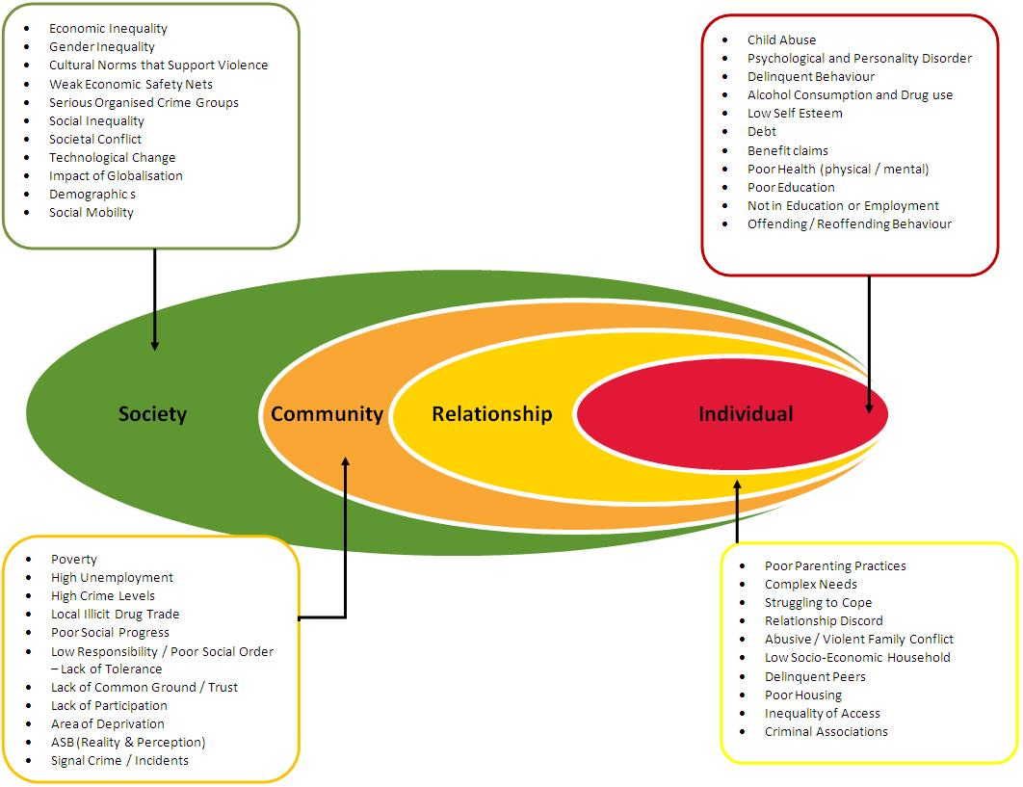

4 Performance
The Strategy Group has a performance scorecard which reflects each of the priorities and key issues identified by the strategic assessment of crime and disorder. The full scorecard and highlight report are attached.
Multi-Agency Data Exchange (MADE) is an online resource funded by partners which provides data and intelligence for use by community safety practitioners. MADE and the scorecard can also be accessed via the partnership website at www.saferlancashire.co.uk.

Mel Ormesher
Community Safety Manager, Lancashire County Council
mel.ormesher@lancashire.gov.uk
Helen Denton
Executive Director Adult and Community Services, Lancashire County Council
Chair, Lancashire Community Safety Strategy Group

